

Name: VANSH GUPTA

Object Oriented Programming (OOP) Laboratory File

Sap ID: 500123239
Enrollment No: R2142230209
Batch: B4

Experiment 4
Classes (Constructors, Access Modifiers, Method
Overloading, Static & Non-Static Members, this)

Book Class (Constructors and Overloading)
Create a Book class with the following features:
- Attributes: title and author
- Assign default values (e.g., "Untitled", "Unknown Author")
- Accept user-defined values for title and author
- Add another constructor that also includes an integer parameter for publicationYear
Objective:
- Create multiple Book objects using different constructors and display their details.

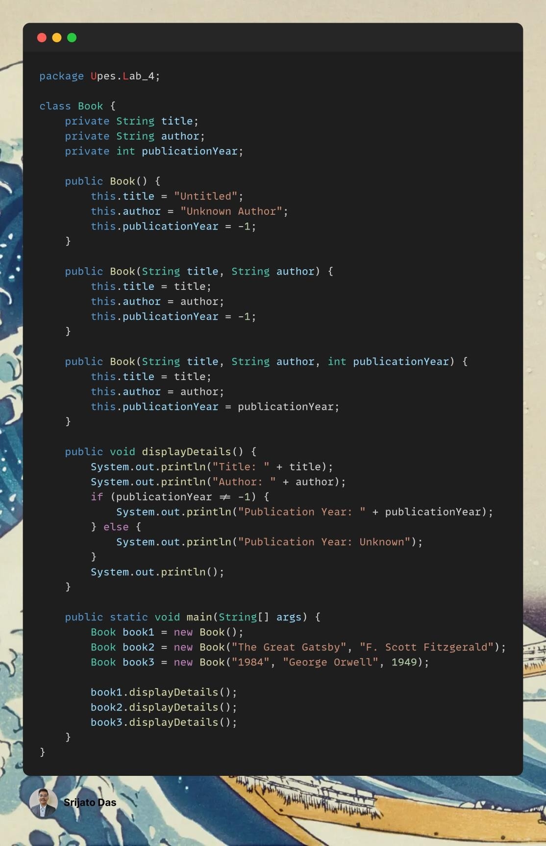

Customer Class (Access Modifiers and Method Overloading)
Declare a Customer class with the following features:
- A private variable balance
- A public method addBalance(double amount) to add funds
- A protected method deductBalance(double amount) to reduce funds
- A default-access (package-private) method showBalance() to display the current balance
- Method overloading for addBalance(...), allowing it to also accept an int amount for smaller deposits Objective:
- Create an instance of the Customer class
- Showcase method overloading for different deposit parameters

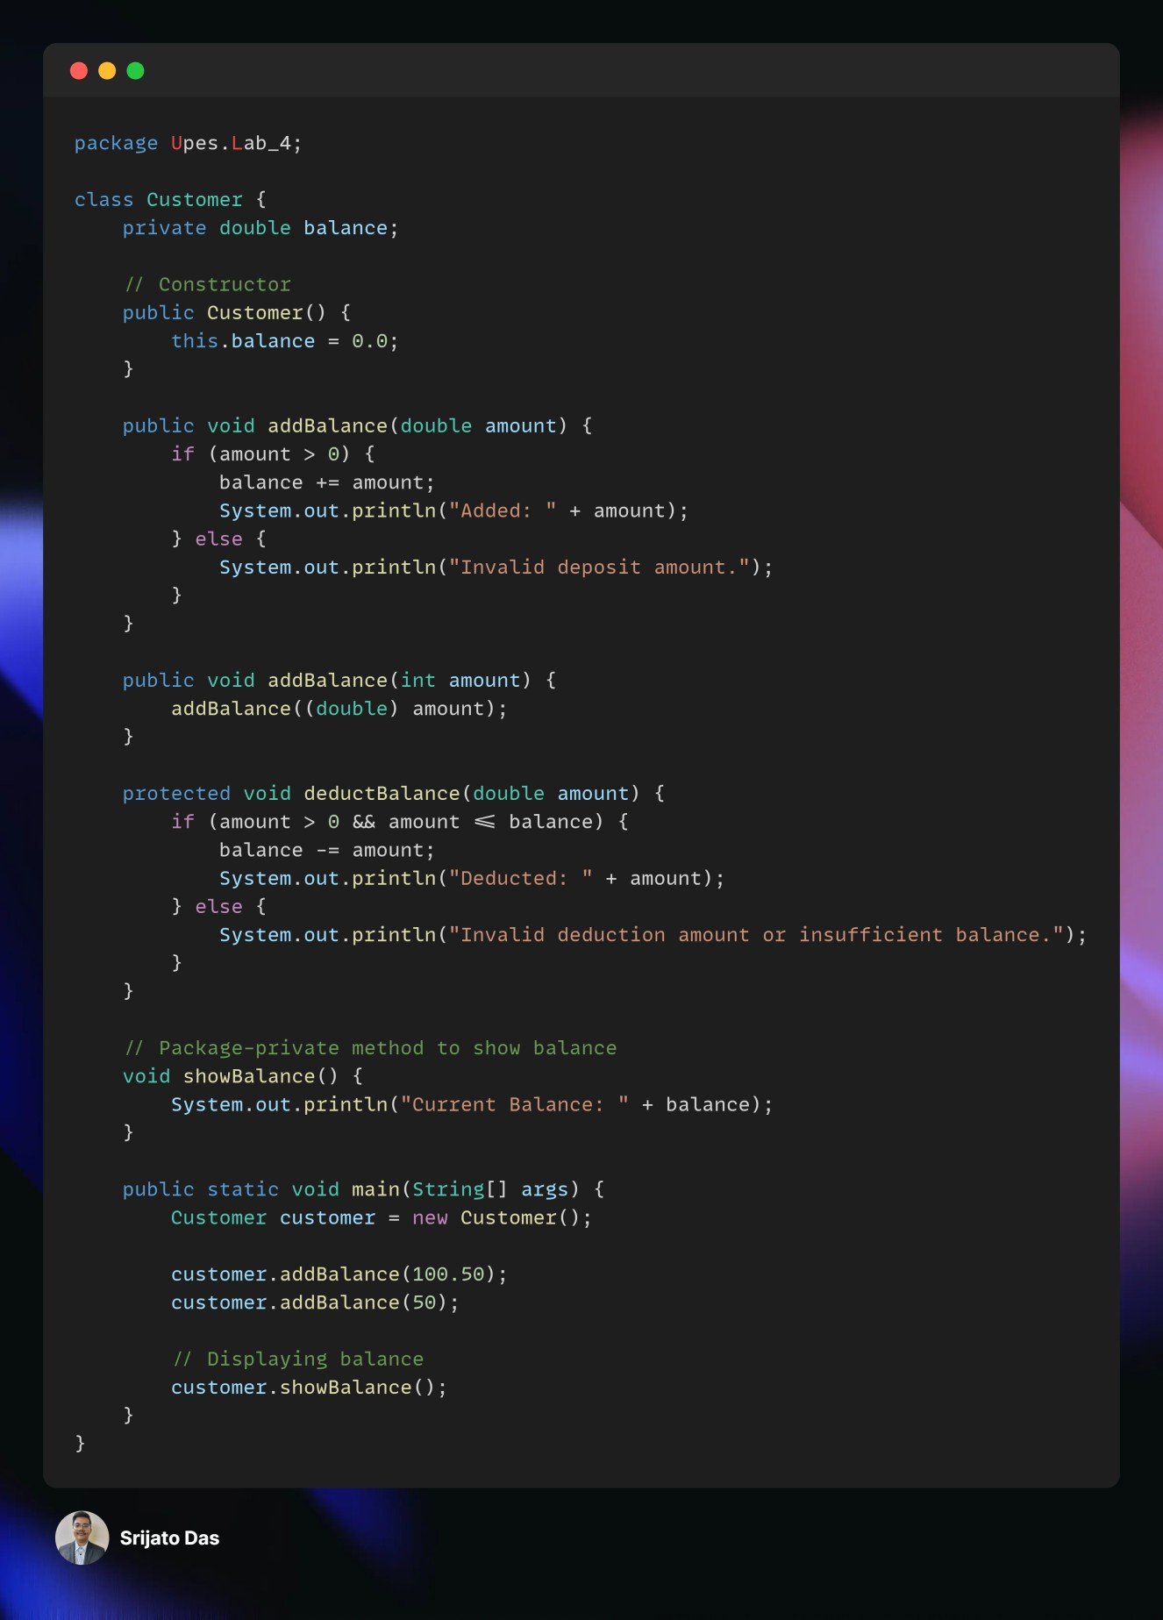

Club Class (Static & Non-Static Members)
Create a Club class with the following features:
- A static variable clubName (shared across all instances)
- A non-static variable memberName (unique to each object)
- A static method displayClubName() to print the club’s name Objective:
- Create multiple Club objects and assign different member names to each
- Show how clubName is shared across all instances, while memberName remains unique
- Display each member’s name alongside the shared club name

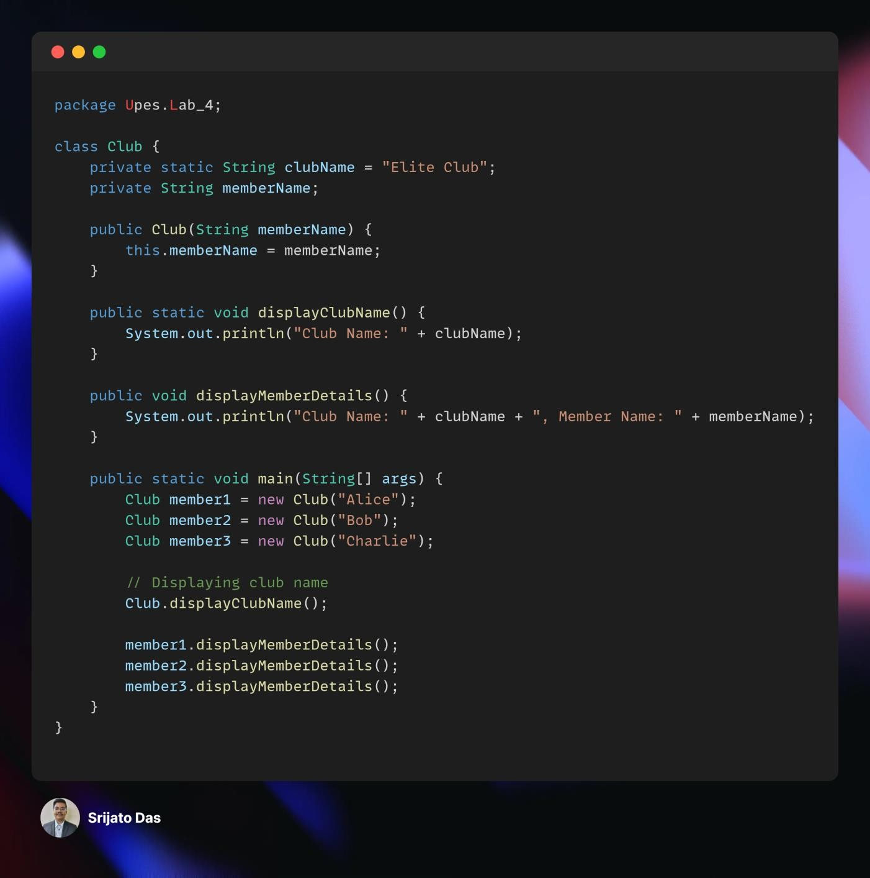

Car Class (this Keyword and Parameterized Constructor)
Define a Car class with the following features:
- Attributes: make, model, and year
- A parameterized constructor that uses the this keyword to differentiate parameters from class fields (e.g., this.make = make;) Objective:
- Instantiate a Car object with specific values (e.g., "Tesla", "Model 3",
2025)
- Display its details, ensuring correct assignment of attributes using this

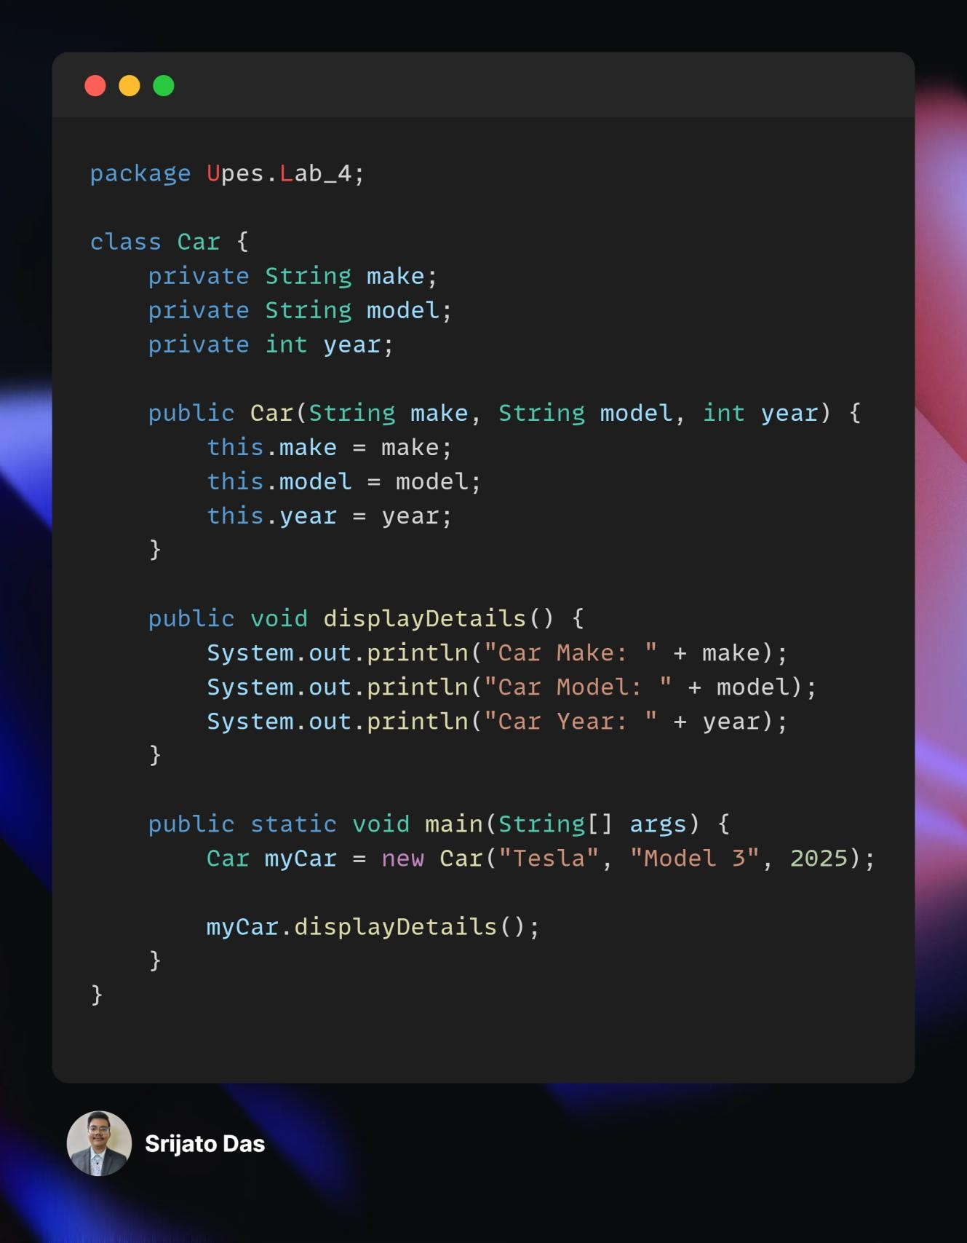

Product Class (Static Members, Stock Value Calculation & Method Overloading)
A company wants to manage a list of products with details such as product ID, name, price, and category.
Product Class Features:
Instance Variables:
- productId, productName, category
- A private variable price
Constructors:
- A default constructor setting some default values
- A parameterized constructor that initializes product details using this
Methods:
- A public method getPrice() to access the private price
- A public method displayProductInfo() to show all details
Static Members:
- A static variable totalProducts to count how many Product objects are created
- A static method displayTotalProducts() to print the total count
Method Overloading for Stock Value Calculation:
- A method calculateStockValue() to multiply the price by a given quantity
- Overloaded version with an optional discount rate Objective:
- Create multiple Product objects using both default and parameterized constructors
- Call the static method to display the total number of products
- Display each product’s details, including the price and the calculated stock value for a given quantity

